DATA ANALYTICS WITH TABLEAU

ASSIGNMENT – 3

O.Kusuma

20NN1A0536

IV – BTECH(CSE)

VNITSW

DATASET : [Sample - Superstore.xls](https://docs.google.com/spreadsheets/d/1Vmsk3xJ_qp69U0AZzCpNybqX0AP4KSon/edit#gid%3D972120833)



* Define at least two sets based on specific criteria from your dataset (e.g., high-value customers, top-performing products).
* Experiment with combining sets using UNION, INTERSECT, and MINUS operations.
* Create 2 Calculation field using any aggregate function
* Create any 3 visualization using quick Table Calculations

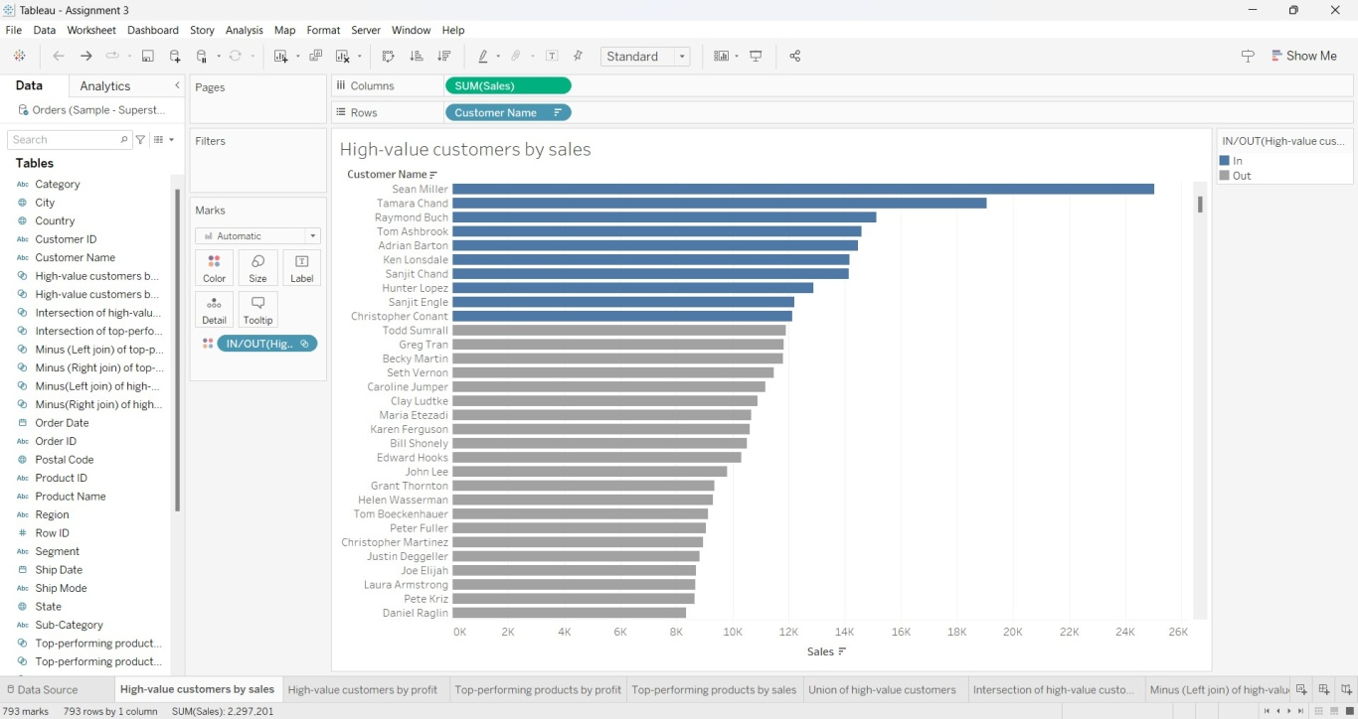HIGH-VALUE CUSTOMERS BY SALES

HIGH-VALUE CUSTOMERS BY PROFIT

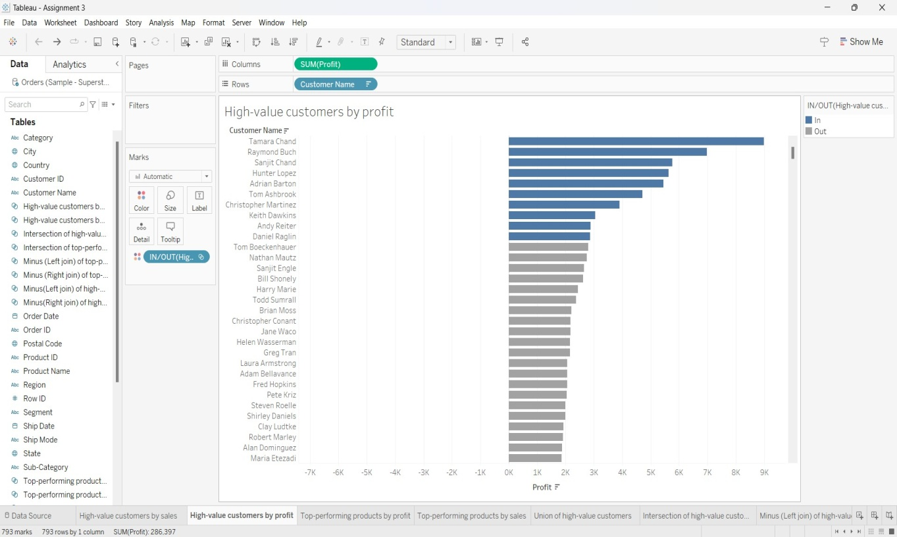

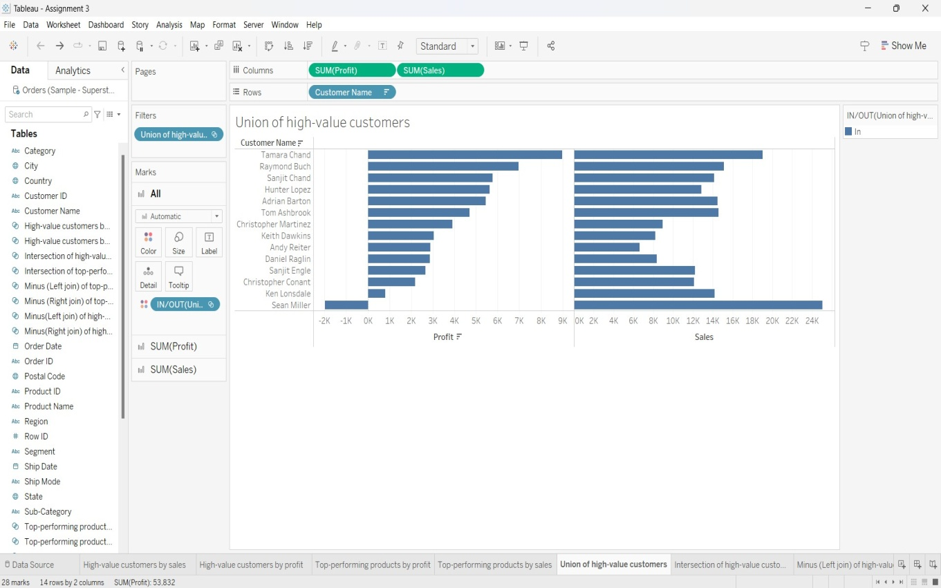UNION OF HIGH-VALUE CUSTOMERS

INTERSECTION OF HIGH-VALUE CUSTOMERS

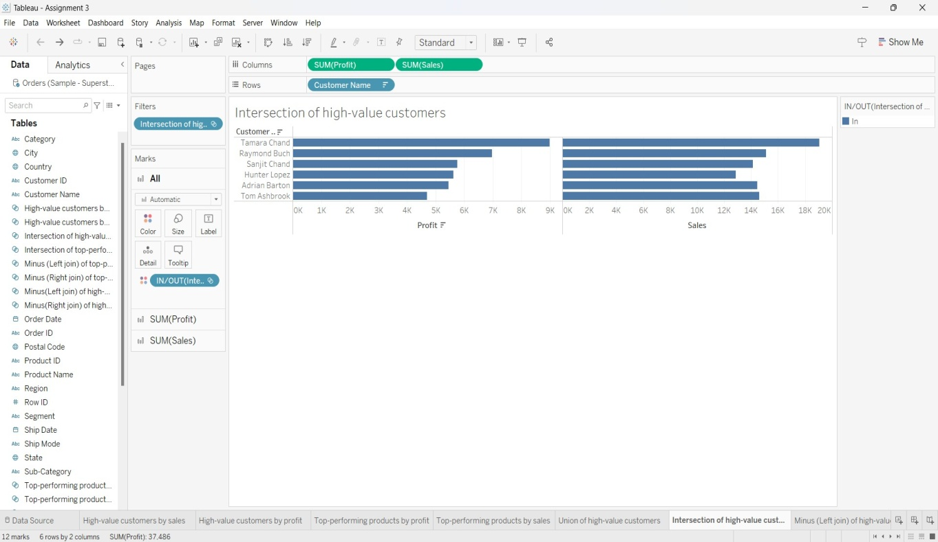

MINUS (LEFT JOIN) OF HIGH-VALUE CUSTOMERS

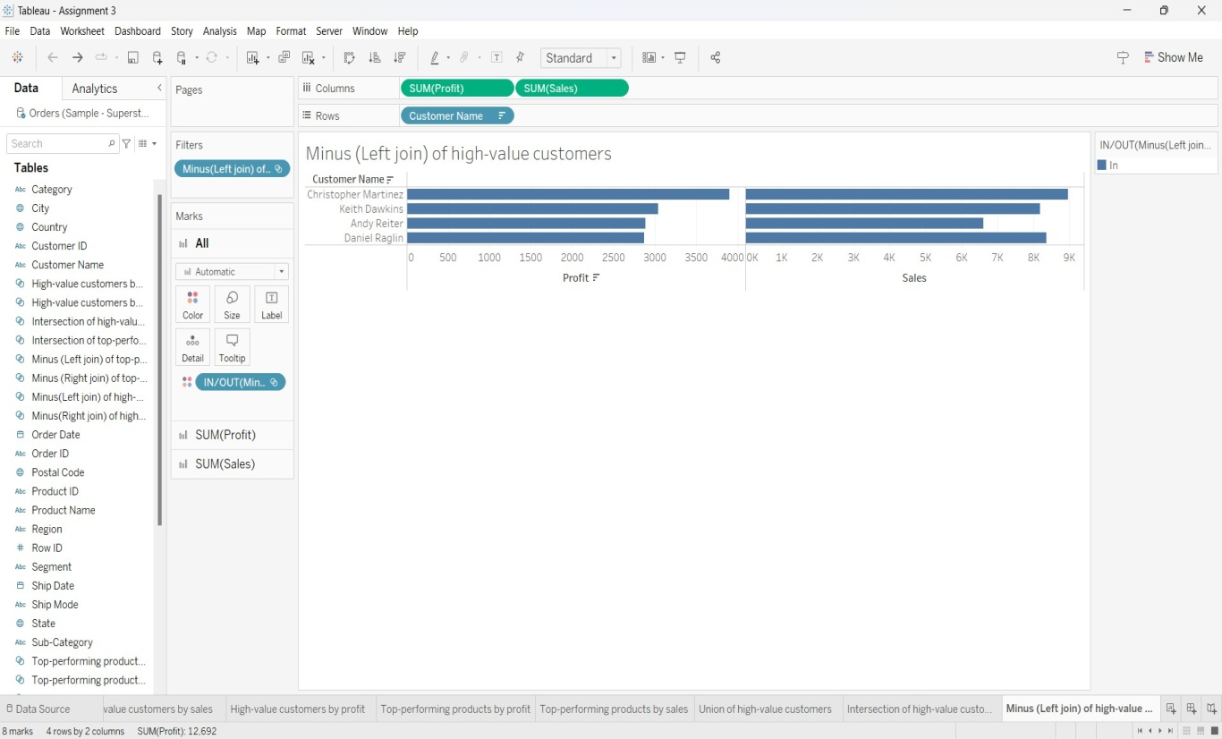

MINUS (RIGHT JOIN) OF HIGH-VALUE CUSTOMERS

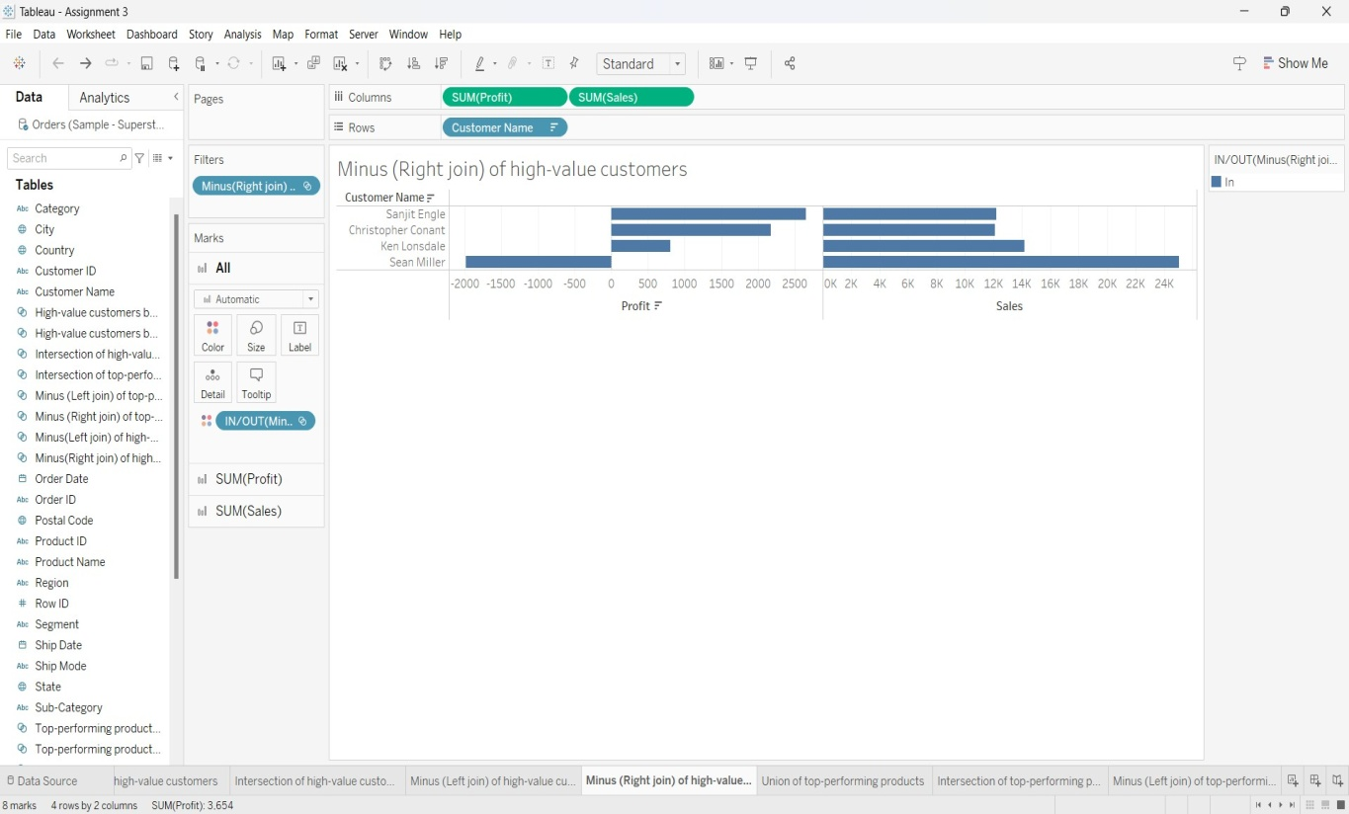

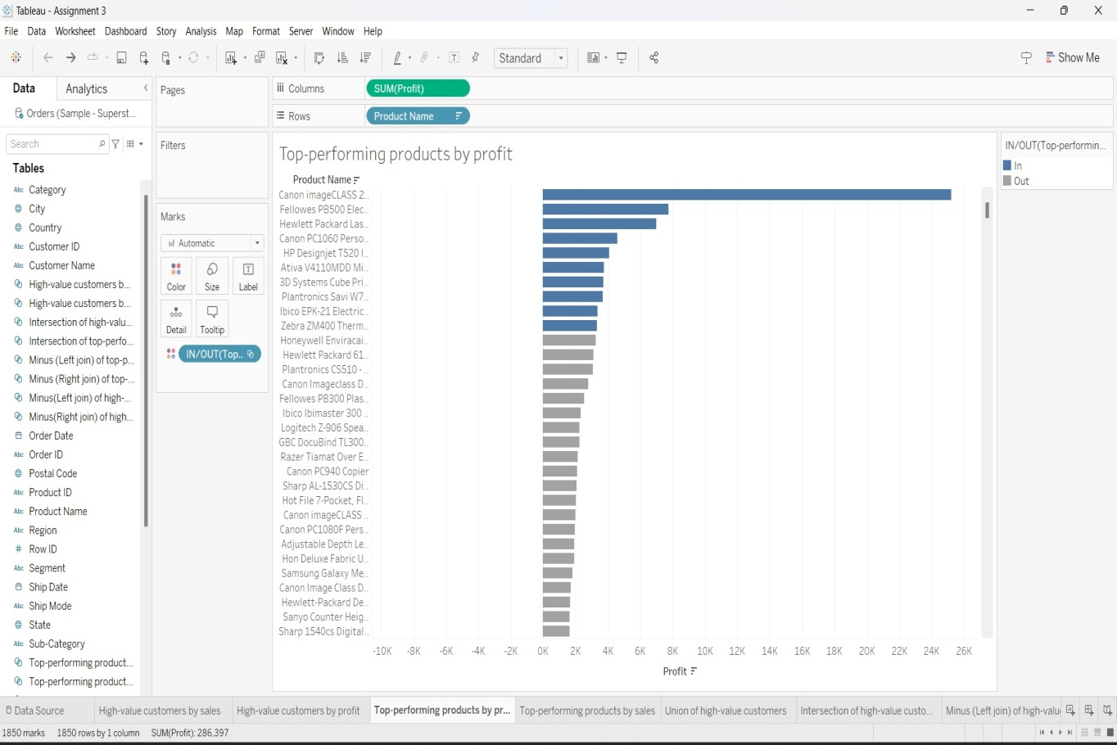TOP-PERFORMING PRODUCTS BY PROFIT

TOP-PERFORMING PRODUCTS BY SALES

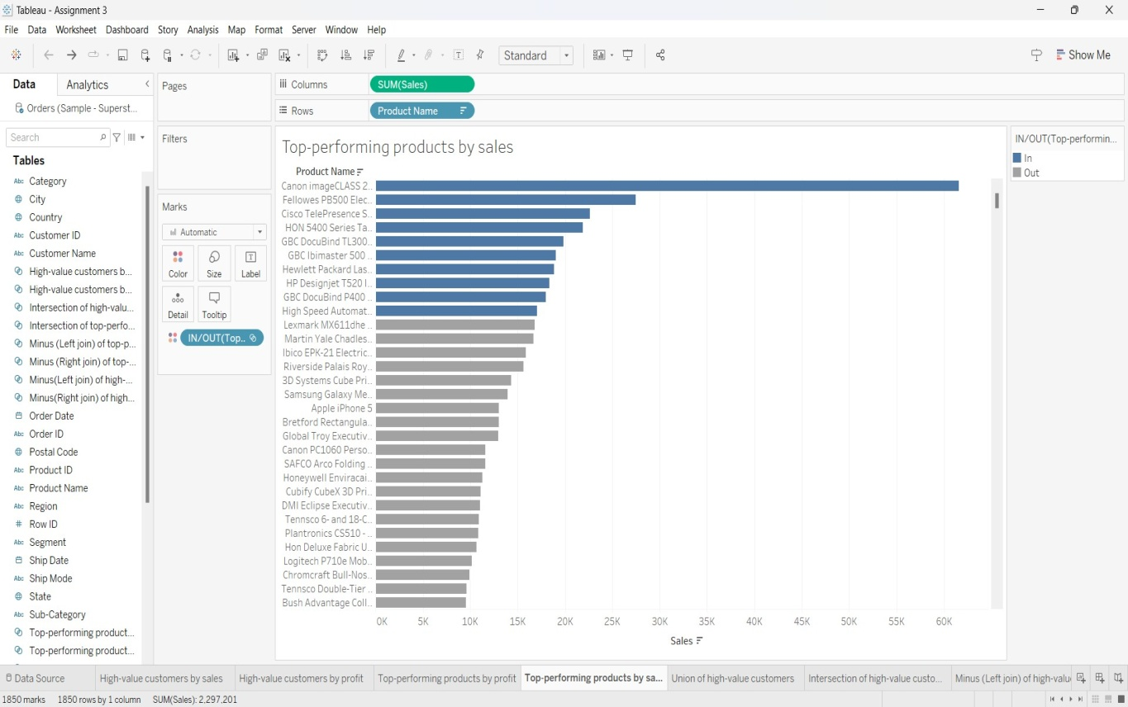

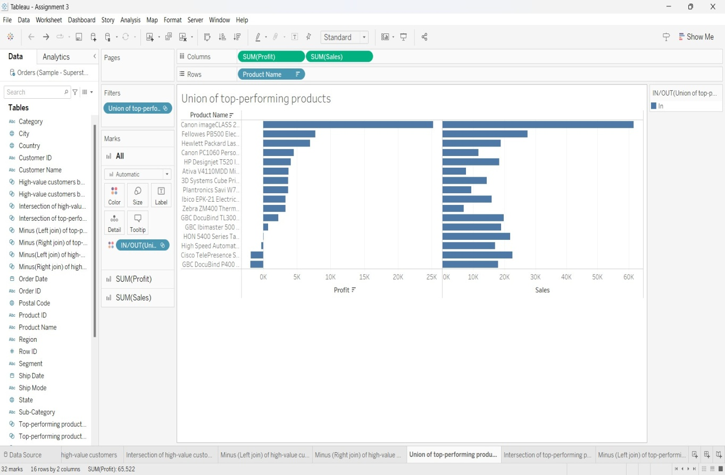UNION OF TOP-PERFORMING PRODUCTS

INTERSECTION OF TOP-PERFORMING PRODUCTS

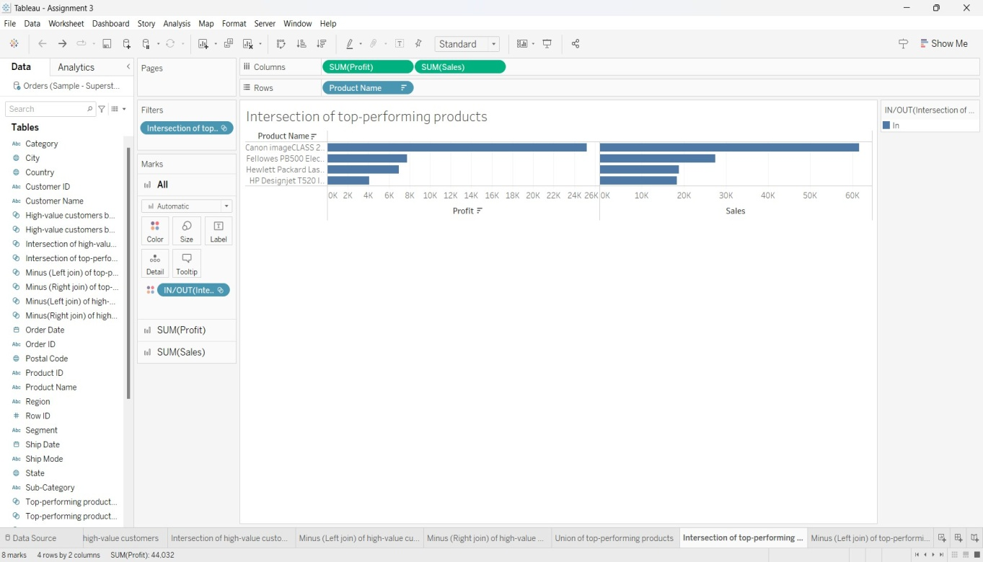

MINUS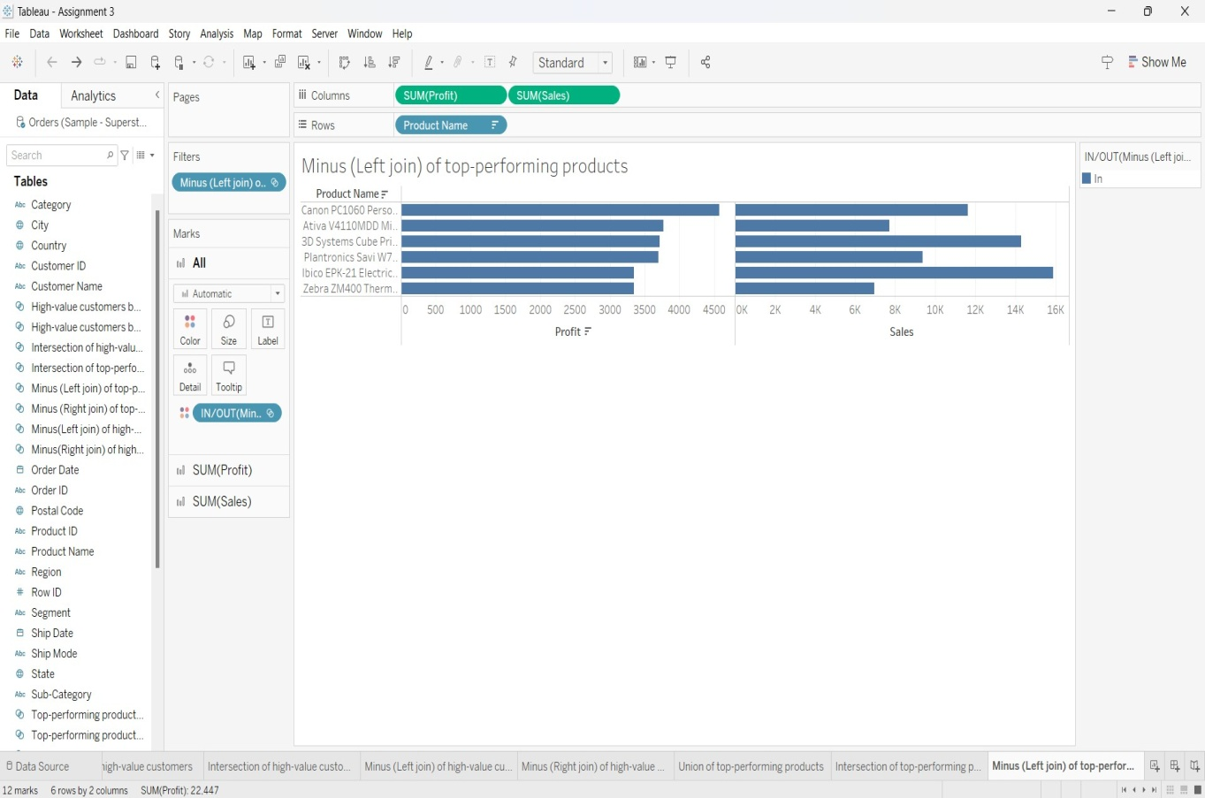(LEFT JOIN) TOP ERFORMING PRODUCTS

MINUS (RIGHT JOIN) OF TOP-PERFORMING PRODUCTS

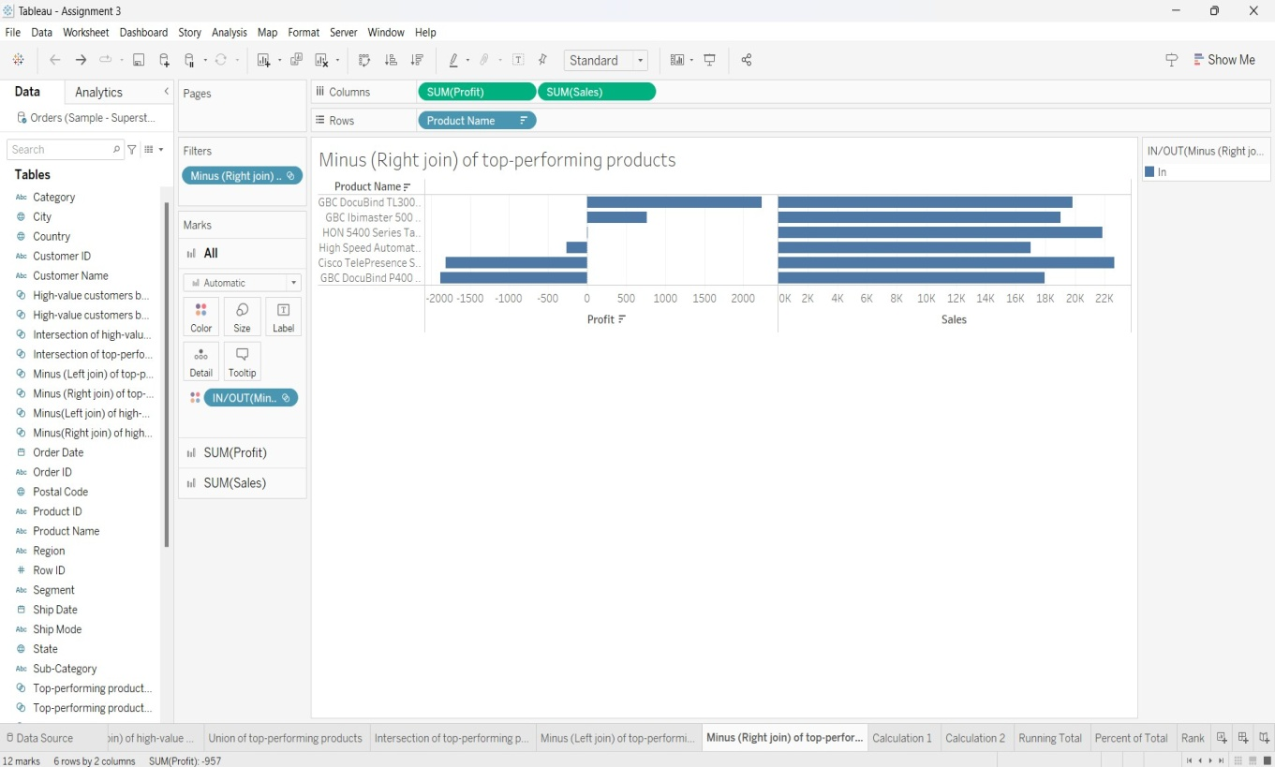

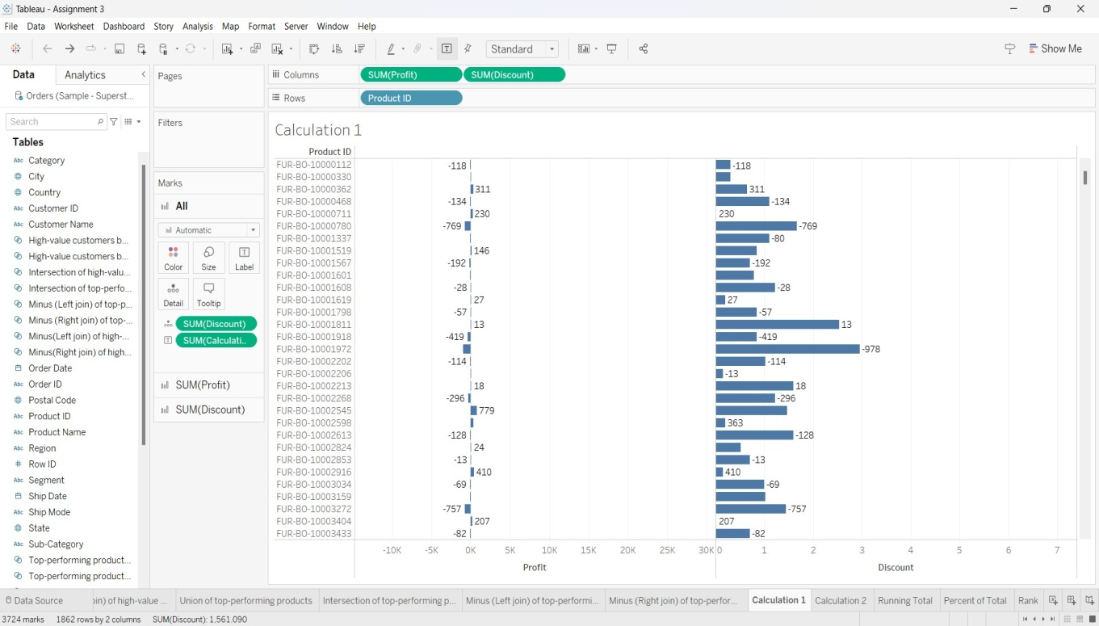CALCULATED FIELD

CALCULATED FIELD- 2

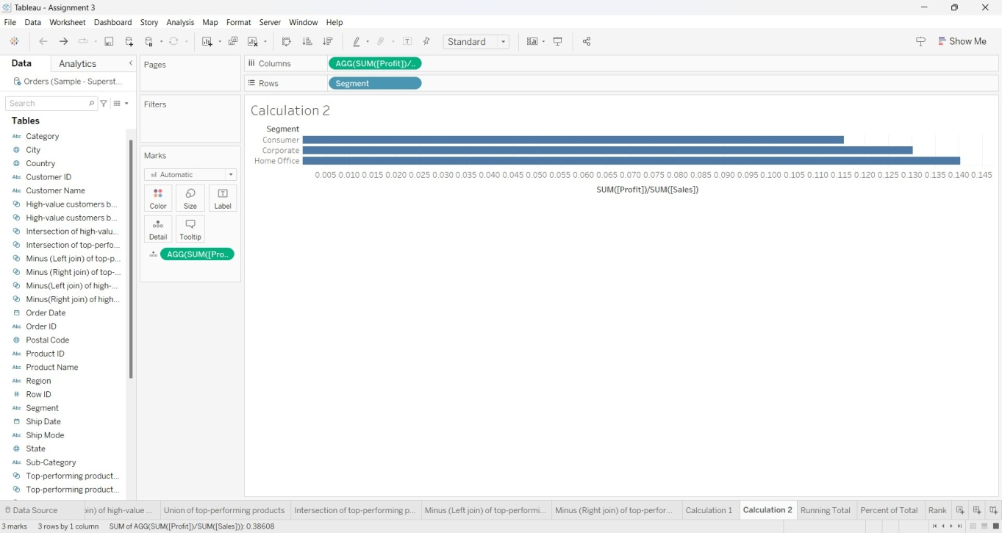

QUICK TABLE CALCULATIONS

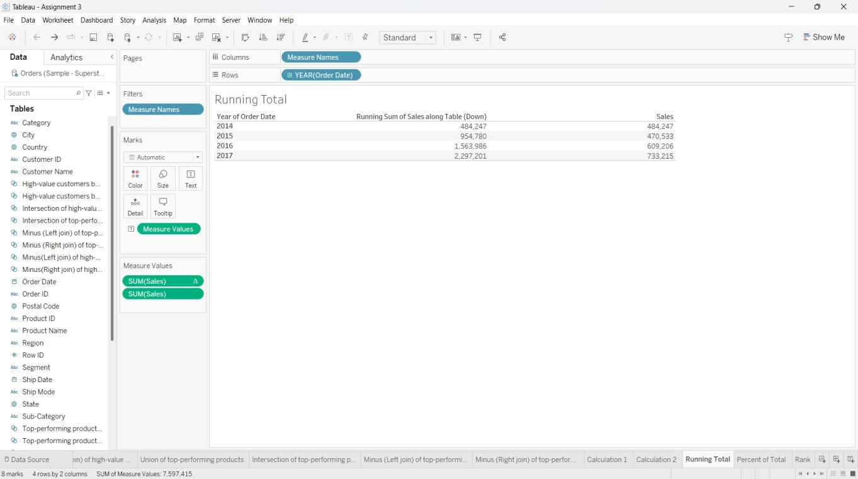RUNNING PROFIT

PERCENT OF TOTAL

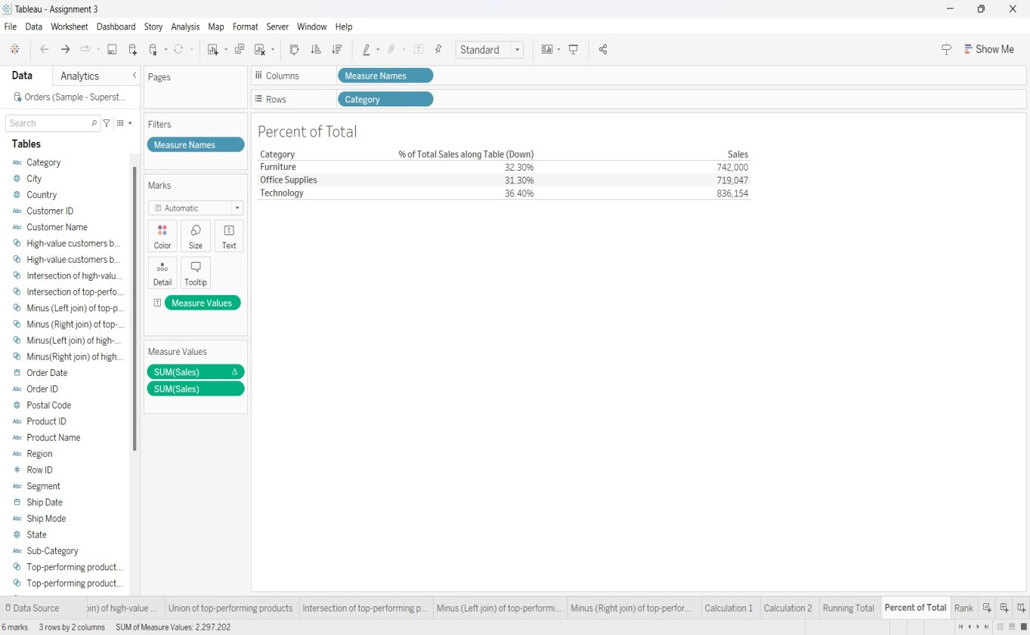

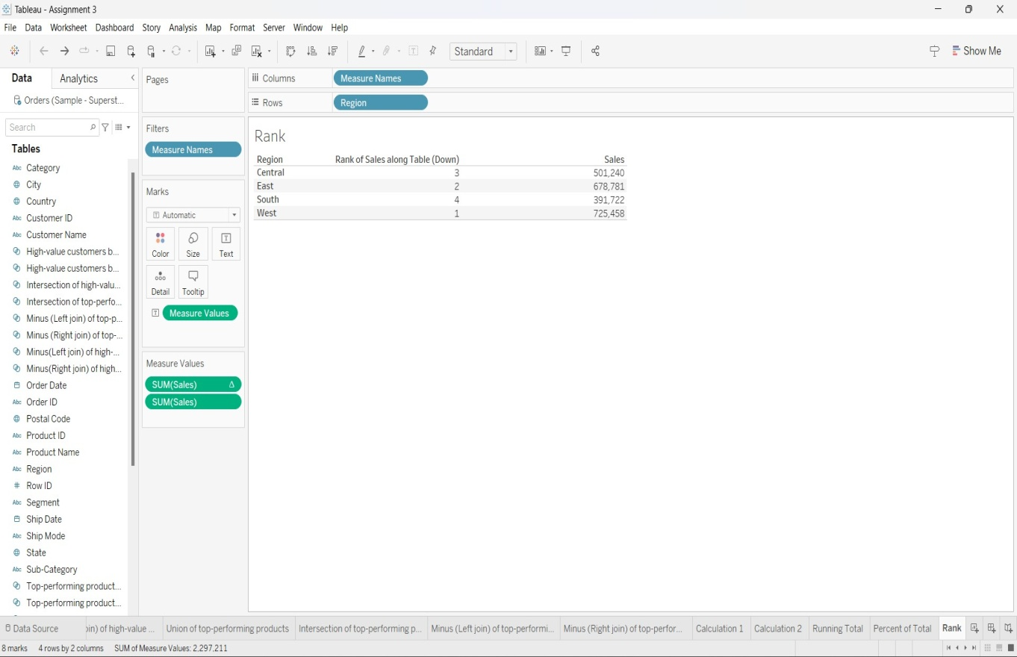RANK